|  |  |  |
| --- | --- | --- |
|  |  | |
|  | | |
|  | |  |
|  | | |
| Huawei eSight for vROps Plug-in | |  |
| **User Guide** | |  |
|  | | |
| V2.0.1 | |  |
|  | | |
| Issue:01  Date:2021-01-27 | |  |
|  | | |
|  | Copyright © Copyright Holder. All rights reserved. | |

|  |  |  |  |
| --- | --- | --- | --- |
|  |  | | |
|  | | | |
|  | **Notice** |  | |
|  | The information in this document is subject to change without notice. Every effort has been made in the preparation of this document to ensure accuracy of the contents, but all statements, information, and recommendations in this document do not constitute the warranty of any kind, express or implied. |  |

Contents

Preface 1

1 Overview 1-1

2 Installing and Uninstalling the Huawei vROps Plug-in 2-1

2.1 Installing the Huawei vROps Plug-in 2-1

2.2 Uninstalling the Huawei vROps Plug-in 2-4

3 Configuring an eSight Instance 3-1

3.1 Addition 3-1

3.2 Modification 3-5

3.3 Deletion 3-7

4 Querying Server Information 4-1

4.1 Querying the Server List 4-1

4.2 Querying Component Information 4-3

4.3 Adding a Component View 4-6

4.4 Locating Alert Information 4-11

5 Querying the Huawei vROps Plug-in Version 5-1

6 FAQs 6-1

6.1 Connection Test Failed When Adding an eSight 6-1

A Getting Help 1

A.1 Collecting Fault Information 1

A.2 Preparing for Debugging 1

A.3 Using Product Documentation 1

A.4 Obtaining Technical Support 1

Preface

Overview

This guide describes how to install and maintain Huawei vRealize Operations Manager (vROps) plug-in.

Intended Audience

This document is intended for:

* Technical support engineers
* System maintenance engineers

Symbol Conventions

The symbols that may be found in this document are defined as follows.

| Symbol | Description |
| --- | --- |
|  | Indicates an imminently hazardous situation which, if not avoided, will result in death or serious injury. |
|  | Indicates a potentially hazardous situation which, if not avoided, could result in death or serious injury. |
|  | Indicates a potentially hazardous situation which, if not avoided, may result in minor or moderate injury. |
|  | Indicates a potentially hazardous situation which, if not avoided, could result in equipment damage, data loss, performance deterioration, or unanticipated results.  NOTICE is used to address practices not related to personal injury. |
|  | Calls attention to important information, best practices, and tips.  NOTE is used to address information not related to personal injury, equipment damage, and environment deterioration. |

Change History

| Issue | Date | Description |
| --- | --- | --- |
| 01 | 2021-01-27 | This issue is the first official release. |

# Overview

Function Description

The Huawei eSight for vROps plug-in is a plug-in integrated in the vRealize Operations Manager software and used for Huawei server management. By adding eSight, it can monitor Huawei servers. Only vRealize Operations Manager 8.0 and 8.1 are supported. In this document, vRealize Operations Manager 8.1 is used as an example.

You can implement the following functions by using the Huawei eSight for vROps plug-in:

* Query server lists.
* Query basic information of server components.
* Query alarm information and health status of servers.

Supported Servers

Table 1-1 lists the servers supported by the Huawei eSight for vROps plug-in.

Supported servers

| Type | Server Model |
| --- | --- |
| Rack server | RH1288 V3 |
| RH2288H V2 |
| RH2288 V3 |
| RH2288H V3 |
| RH5885 V3 |
| RH5885H V3 |
| RH8100 V3 |
| 1288H V5 |
| 2288H V5 |
| 2488 V5 |
| Blade server | CH121 V3 |
| CH242 V3 |
| Chassis | E9000 (MM910) |
| High-density server | XH321 V3 |
| XH620 V3 |
| XH622 V3 |
| XH628 V3 |
| KunLun server | 9008 |
| 9016 |
| 9032 |

# Installing and Uninstalling the Huawei vROps Plug-in

2.1 Installing the Huawei vROps Plug-in

2.2 Uninstalling the Huawei vROps Plug-in

## Installing the Huawei vROps Plug-in

Access [GitHub](https://github.com/Huawei/Huawei_FusionDirector_For_vROps/tree/master/release) and download the latest Huawei vROps plug-in installation package, such as **Huawei_eSight_For_vROps_***X.X.X***.zip**.

Decompress the installation package.

Obtain the installer, such as **HuaweieSightManagementPack_***X.X.X***.pak**.

On the vROps WebUI, choose **Administration**.

The **Administration** page is displayed.

In the navigation pane on the left, choose **Repository**.

The **Repository** page is displayed.

In the lower part of the page, click **ADD/UPGRADE**.

The **Add Solution** dialog box is displayed, as shown in Figure 2-1.

Add Solution

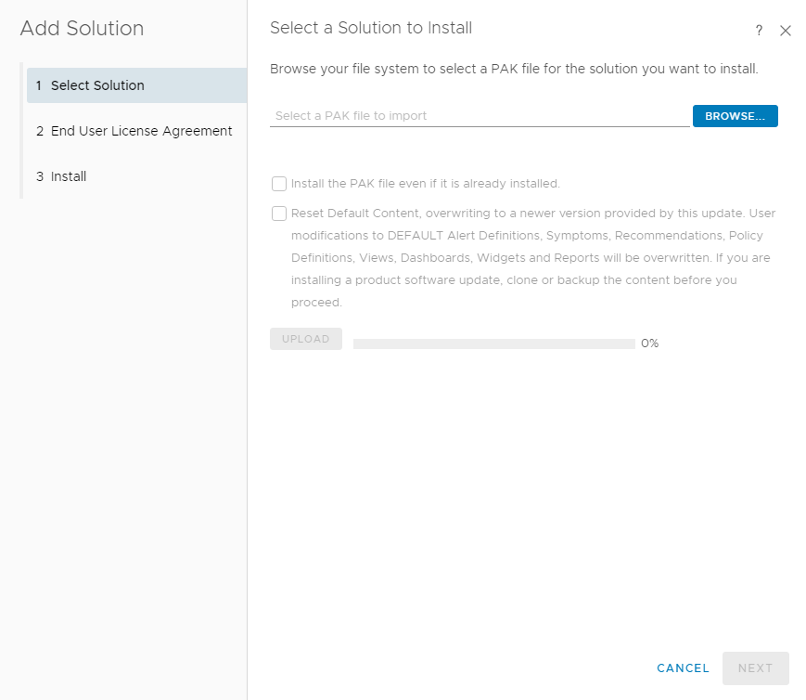

On the **Select Solution** tab page, click **BROWSE** and select the plug-in installation file.

Select **Install the PAK file even if it is already installed**.

Click **UPLOAD** and upload the installation file.

Click **NEXT**.

The **Confirmation** dialog box is displayed.

Click **Yes**.

The **End User License Agreement** tab page is displayed, as shown in Figure 2-2.

End User License Agreement

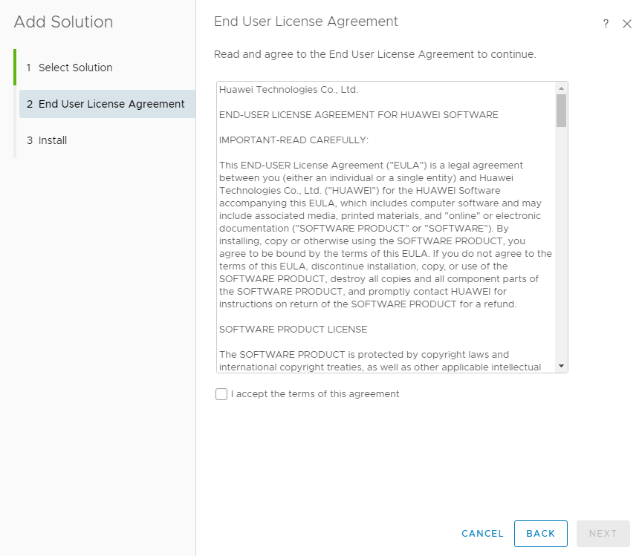

Select **I accept the terms of this agreement** and click **NEXT**.

The **Installation** tab page is displayed.

After the installation is complete, click **FINISH**.

In the lower part of the **Repository** page, view the installed Huawei vROps plug-in, as shown in Figure 2-3.

Viewing the installed vROps plug-in

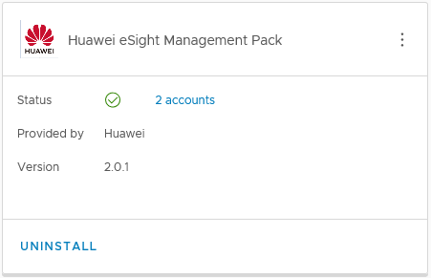

----End

## Uninstalling the Huawei vROps Plug-in

On the vROps WebUI, choose **Administration**.

The **Administration** page is displayed.

In the navigation pane on the left, choose **Repository**.

The **Repository** page is displayed.

In the lower part of the page, select the Huawei vROps plug-in to be uninstalled and click **UNINSTALL**, as shown in Figure 2-4.

Uninstalling the vROps plug-in

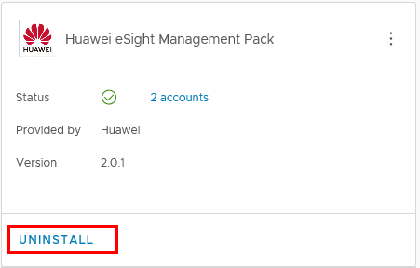

The **Warning** dialog box is displayed, as shown in Figure 2-5.

Warning dialog box

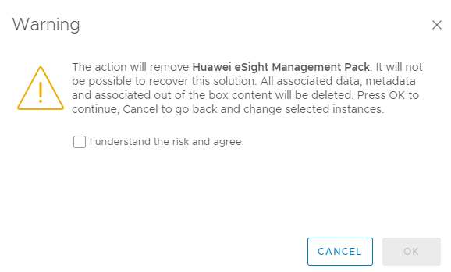

Select **I understand the risk and agree.** and click **OK**.

The Huawei vROps plug-in is uninstalled.

----End

# Configuring an eSight Instance

3.1 Addition

3.2 Modification

3.3 Deletion

## Addition

Set the whitelist.

By default, a whitelist of eSight northbound interfaces is configured. To add an eSight system properly, you must add the IP address of the server where vROps is located to the whitelist of eSight northbound interfaces.

1. Log in to the eSight WebUI.
2. Choose **System** > **Northbound Intergration** > **Third-party System** > **Create**.

The **Third-party System** page is displayed, as shown in Figure 3-1.

Third-party System

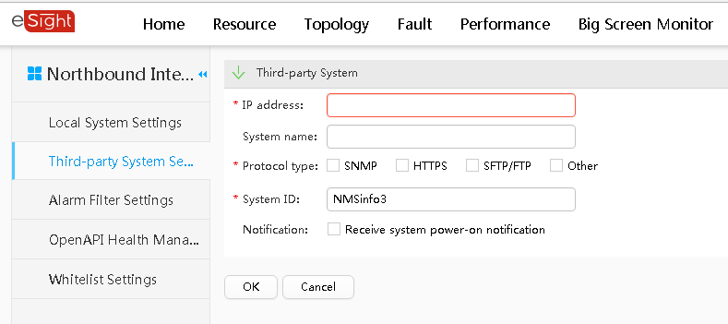

1. Set the following parameters:

* **IP address**: Set it to the IP address of the vROps server.
* **Protocol type**: Select **HTTPS** and deselect other protocols.
* **System ID**: Retain the default value or enter a new value. The value can be an IP address or a string of 1 to 64 characters, including digits 0-9, lowercase letters a-z, uppercase letters A-Z, and special characters @_- (), .^$~`!.

1. Click **OK**.

The IP address of the vROps server is successfully added to the whitelist, as shown in Figure 3-2.

Setting successful

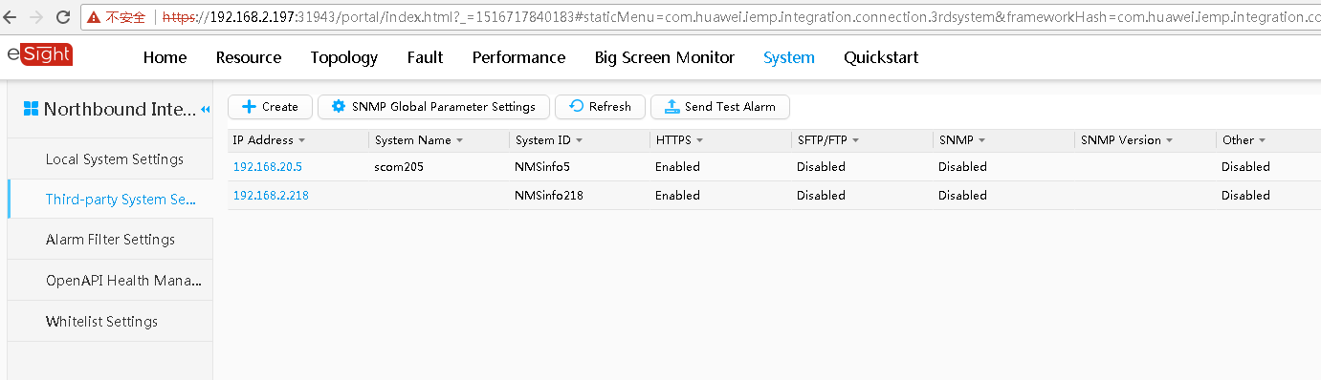

On the vROps WebUI, choose **Administration**.

The **Administration** page is displayed.

In the navigation tree on the left, choose **Other Accounts**.

The **Other Accounts** page is displayed.

Click **ADD ACCOUNT**.

Select the type of the account to be added, for example, **eSight Adapter**.

The **New Account** page is displayed, as shown in Figure 3-3.

New Account

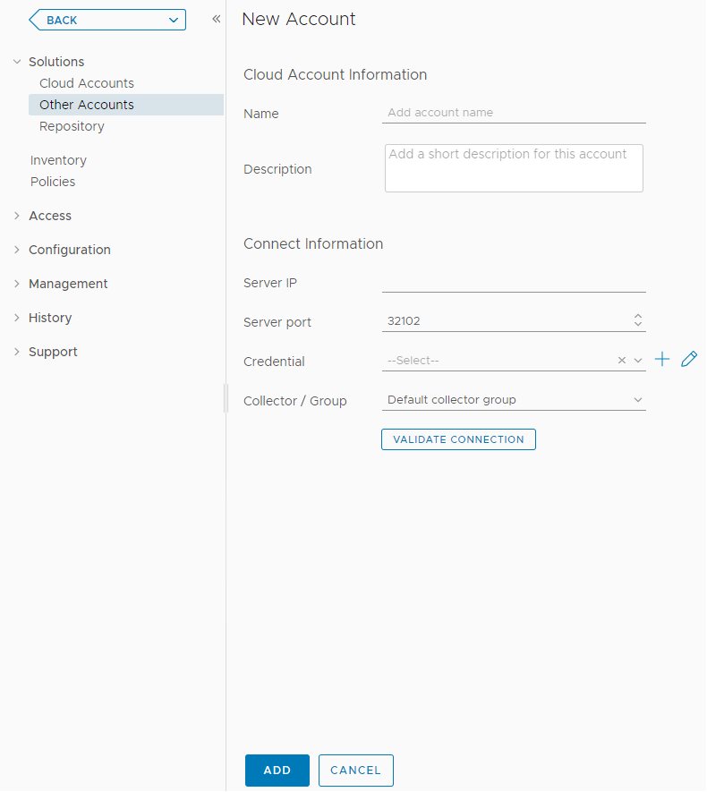

Set the following parameters:

* **Name**: user-defined name to identify different eSight instances
* **Description**: (optional) user-defined description to describe an eSight instance
* **Server IP**: eSight IP address
* **Server Port**: eSight port number, which is **32102** by default.

In the **Credential** field, click .



The **Manage Credentials** dialog box is displayed, as shown in Figure 3-4.

Manage Credentials

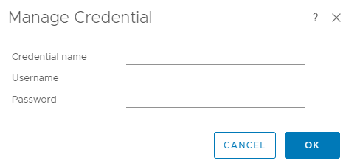

Set the following parameters and click **OK**.

* **Credential name**: user-defined name to identify different credentials
* **Username**: username of the eSight open API to be added. The default username is **openApiUser**.
* **Password**: password of the eSight OpenAPI to be added. The default password is **Changeme_123**.

Click **VALIDATE CONNECTION**.

* If the connection is successful, a test connection success dialog box is displayed. Click **OK**.
* If the connection fails, check whether the eSight IP address, port number, username, and password are correct.
* If no, modify them and click **VALIDATE CONNECTION** again.
* If yes, contact technical support.

Click **ADD**.

The eSight instance is added.

On the **Other Accounts** page, view the added eSight instance, as shown in Figure 3-5.

Viewing the added account

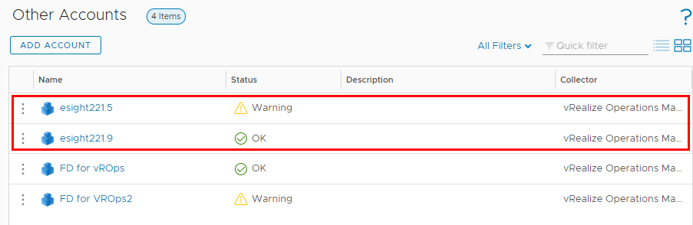

----End

## Modification

On the vROps WebUI, choose **Administration**.

The **Administration** page is displayed.

In the navigation tree on the left, choose **Other Accounts**.

The **Other Accounts** page is displayed, as shown in Figure 3-6.

Other Accounts

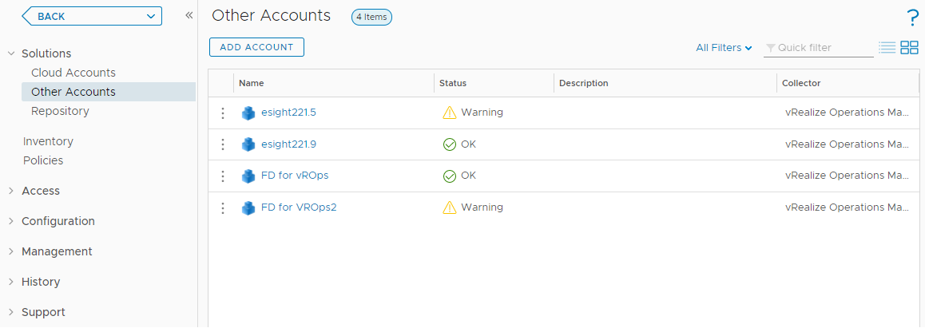

Click the name of the eSight instance to be modified, for example, **esight221.5**.

The eSight instance information page is displayed, as shown in Figure 3-7.

eSight instance information page

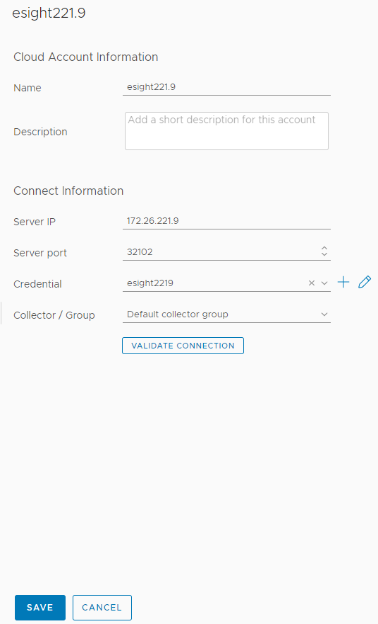

Modify the following parameters as required:

* **Name**: instance name
* **Description**: instance description
* **Server IP**: eSight IP address
* **Server Port**: eSight port number
* **Credential**: Click to change the credential name, eSight username, and password.



If the eSight port number, username, or password is changed after the eSight connection, you need to synchronize the new port number, user name, or password to the eSight. Otherwise, server management is affected.

Check whether the information in the **Connect Information** area is modified.

* If yes, click **VALIDATE CONNECTION**.
* If the connection is successful, a test connection success dialog box is displayed. Click **OK**.
* If the connection fails, check whether the eSight IP address, port number, username, and password are correct.
  1. If no, modify them and click **VALIDATE CONNECTION** again.
  2. If yes, contact technical support.
* If no, go to Step 6.

Click **SAVE**.

The **Other Accounts** page is displayed. You can view the modified eSight information.

----End

## Deletion

On the vROps WebUI, choose **Administration**.

The **Administration** page is displayed.

In the navigation tree on the left, choose **Other Accounts**.

The **Other Accounts** page is displayed, as shown in Figure 3-8.

Other Accounts

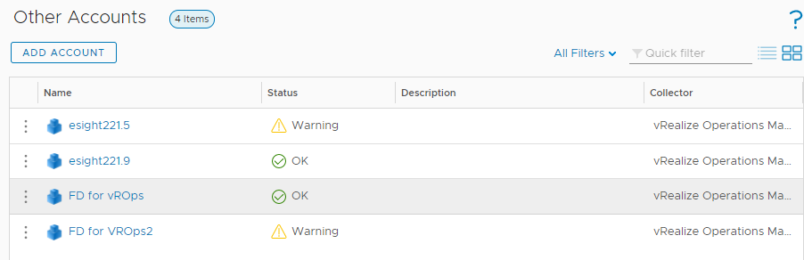

Click next to the name of the eSight instance to be deleted.



The operation selection list is displayed.

Click **Delete**.

A confirmation dialog box is displayed, as shown in Figure 3-9.

Deletion confirmation dialog box

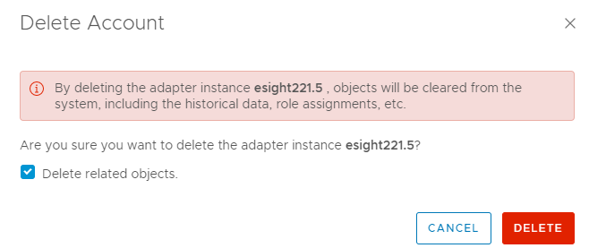

Select **Delete related objects.** (which is selected by default) and click **DELETE**.

The eSight instance is deleted.

----End

# Querying Server Information

4.1 Querying the Server List

4.2 Querying Component Information

4.3 Adding a Component View

4.4 Locating Alert Information

## Querying the Server List

On the vRealize Operations Manager WebUI, select **Environment**.

The **Environment** page is displayed.

In the navigation tree, choose **Huawei eSight Server Management** > **Device Inventory tree**.

The **Device Inventory tree** page is displayed.

In the navigation tree, query the server list, as shown in Figure 4-1.

Device Inventory tree

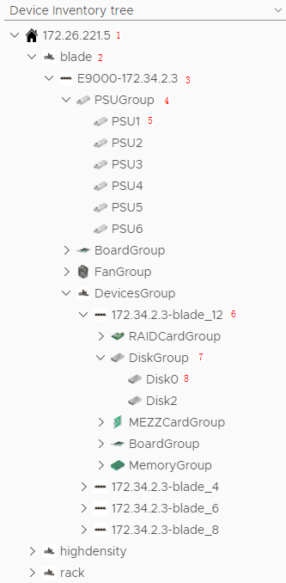

* 1: eSight IP address
* 2: Server type. **blade** indicates a blade server, **highdensity** indicates a high-density server, and **rack** indicates a rack server.
* 3: Server model and iBMC IP address
* 4: Component group
* 5: A component
* 6: IP address and slot number of a management module
* 7: Device group
* 8: A device

----End

## Querying Component Information

On the vRealize Operations Manager WebUI, select **Environment**.

The **Environment** page is displayed.

In the navigation tree, choose **Huawei eSight Server Management** > **Device Inventory tree**.

The **Device Inventory tree** page is displayed.

Choose ***eSight IP address*** > ***Server type*** > ***Server IP address*** > ***Component group*** > ***Component to be viewed***, as shown in Figure 4-2.

Component information

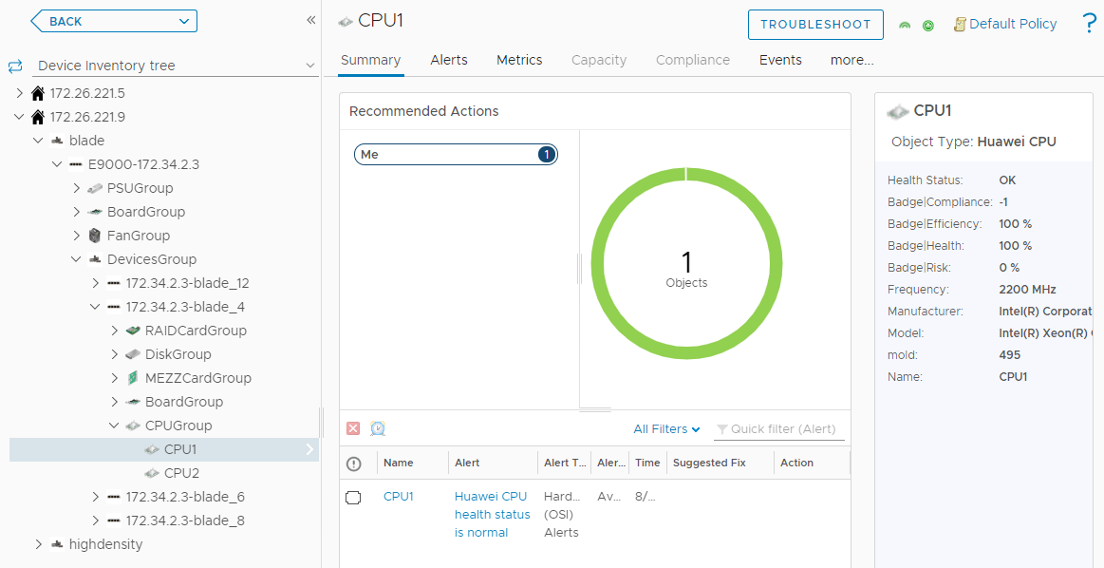

View the summary of the component.

1. Click **Summary**.

The **Summary** page is displayed.

1. In the **Recommended Actions** area, view the running status and alarm information about the component, as shown in Figure 4-3.

Viewing the summary

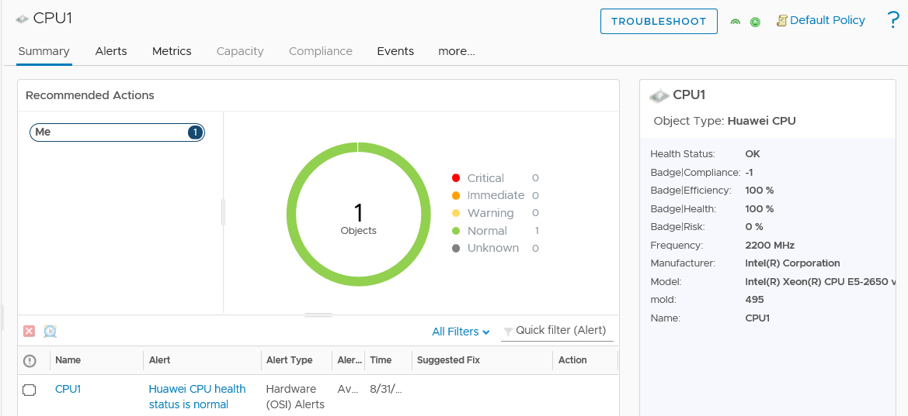

View warning information of the component.

1. Click **Alerts**.

The **Alerts** page is displayed.

1. Select a grouping mode, for example, **Object Type**.
2. Click to expand the warning list.



1. Click a warning name to view details about the warning.

Viewing warning information

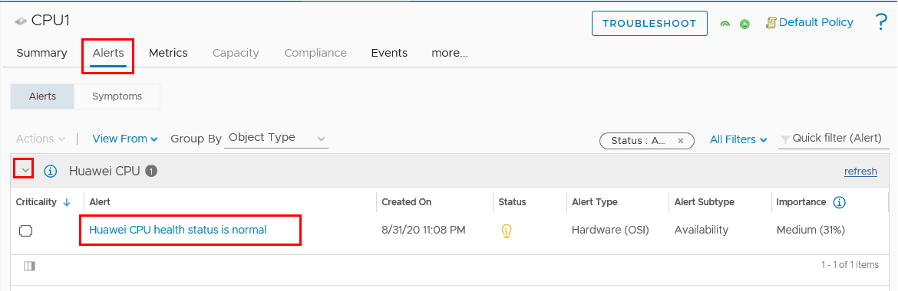

View the real-time status curve of the component.

1. Click **Metrics**.

The **Metrics** page is displayed.

Metrics

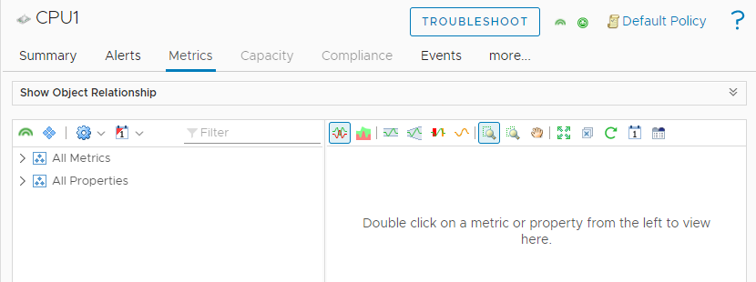

1. Click to expand the information list under **All Metrics** or **All Properties**.



1. Double-click the real-time status information to be viewed. For example, double-click **Health**, as shown in Figure 4-6.

You can view the real-time status curve in the right pane.

Viewing the real-time status curve

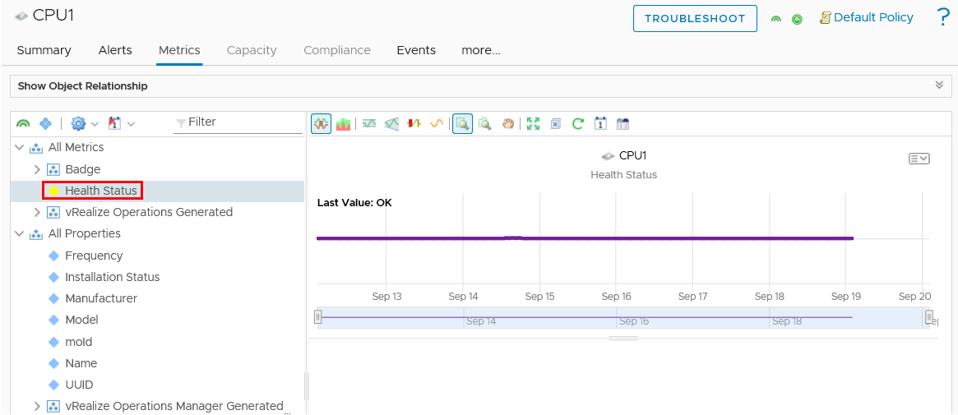

View details about a component view.

1. Click **more** > **Details**.

The **Details** page is displayed.

1. Select a view.
2. View details about the view.

Viewing details about the view

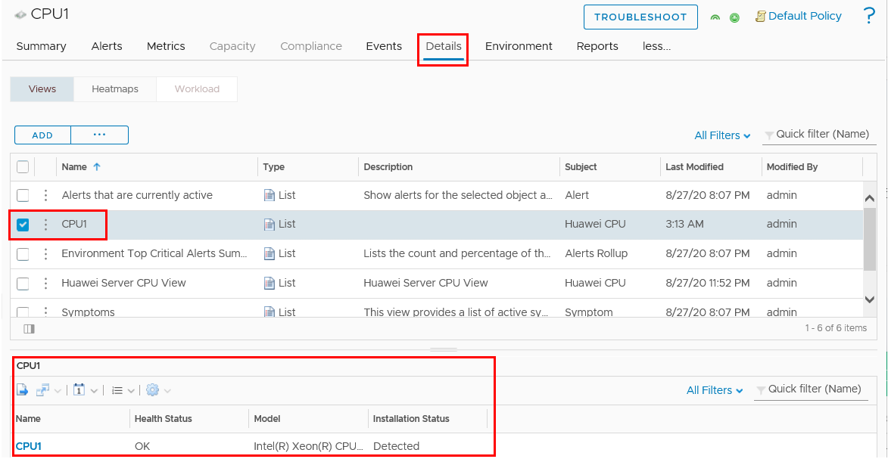

----End

## Adding a Component View

On the vROps WebUI, choose **Environment**.

The **Environment** page is displayed.

In the navigation tree on the left, choose **Huawei eSight Management Pack** > **Device Inventory tree**.

The **Device Inventory tree** page is displayed.

Select an eSight IP address, a server model, a server IP address, a component group, and a component, as shown in Figure 4-8.

Device Inventory tree

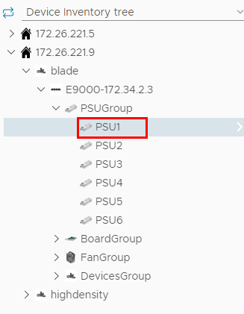

In the right pane, choose **more...** > **Details**.

The **Details** page is displayed, as shown in Figure 4-9.

Details

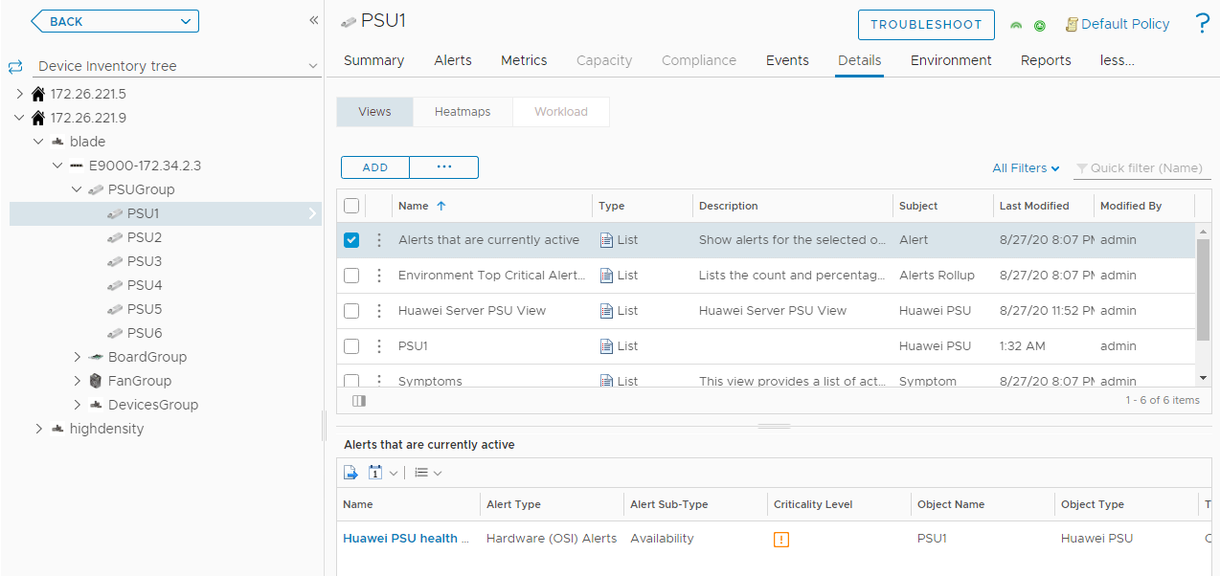

Click **ADD**.

The **New View** dialog box is displayed, as shown in Figure 4-10.

New View

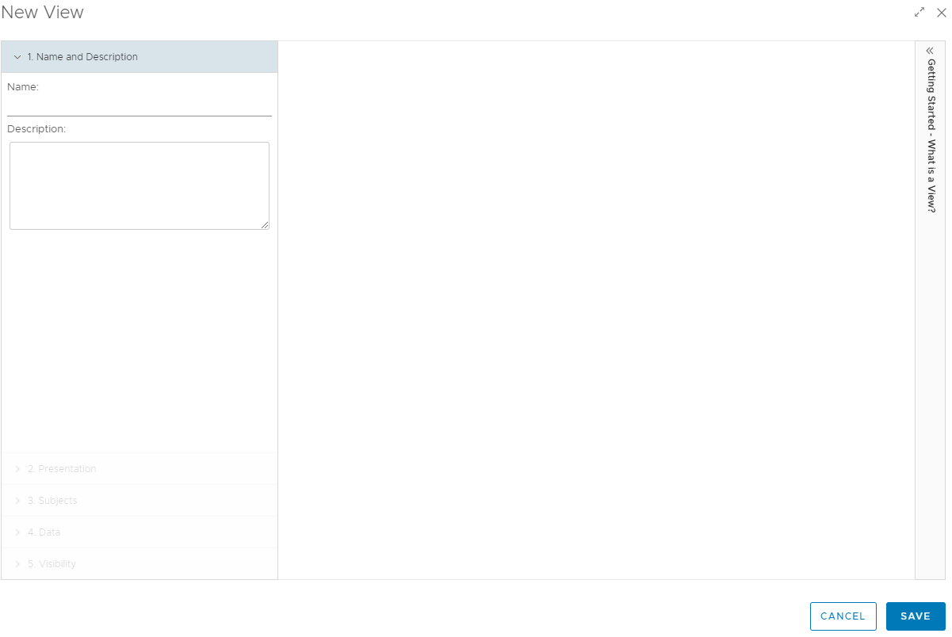

On the **Name and Description** tab page, enter the name and description of the new component view.

On the **Presentation** tab page, select **List** and view the preview effect on the right, as shown in Figure 4-11.

Presentation

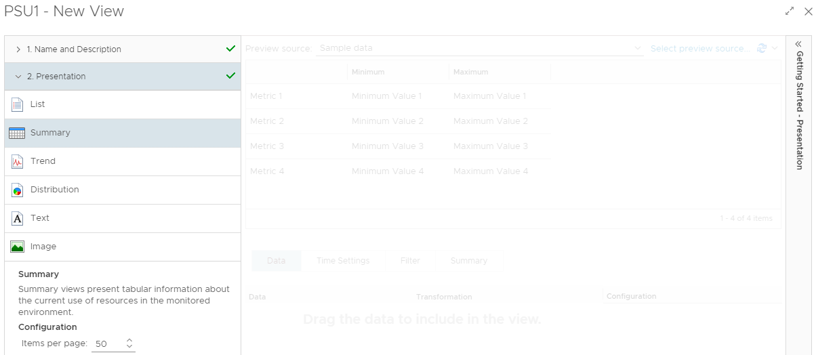

On the **Subjects** tab page, click **eSight Adapter** and choose the type of the component to be added.

For example, to add a component view to PSU1, choose **eSight Adapter** > **Huawei PSU**.

On the **Data** tab page, select **Metrics** or **Properties**, double-click the property marked with , and view the new property in the **Data** area, as shown in Figure 4-12.



Data

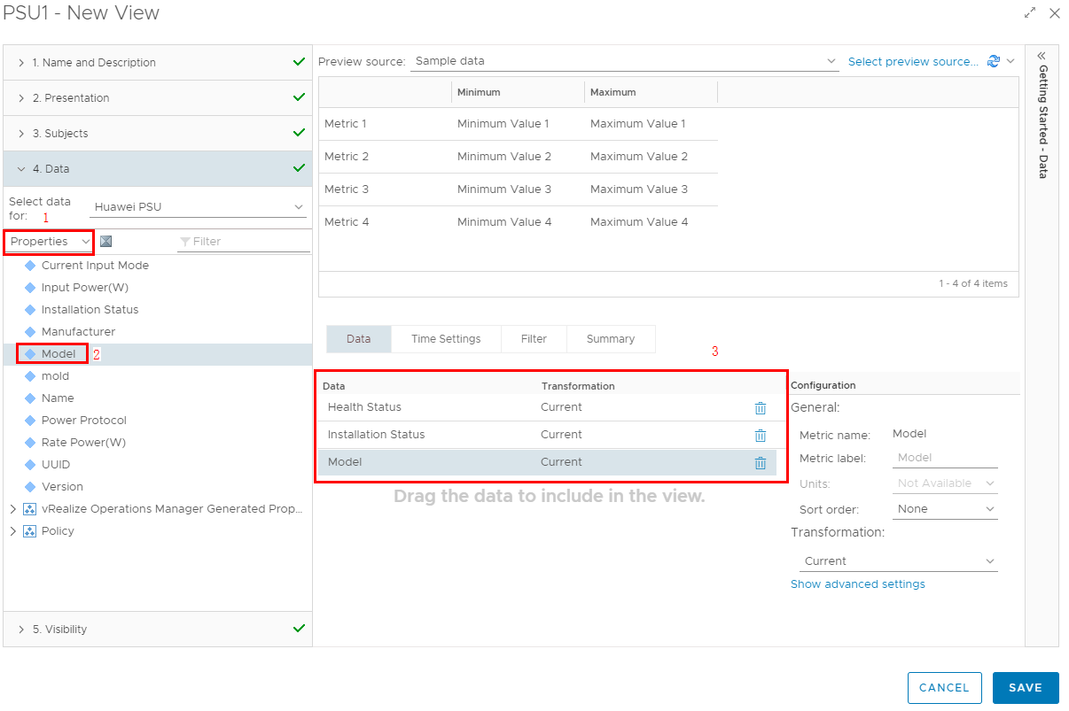

To delete a property, click in the corresponding property column in the **Data** area. For example, to delete the added **Health Status**, click in the **Health Status** column.



On the **Visibility** tab page, retain the default settings and click **SAVE**.

On the **Details** page, view the added component view.

* In **Device Inventory tree**, select a server IP address. In the right pane, choose **Details** and click the added component view to check all views of this component type of this server, as shown in Figure 4-13.

Viewing the component view 1

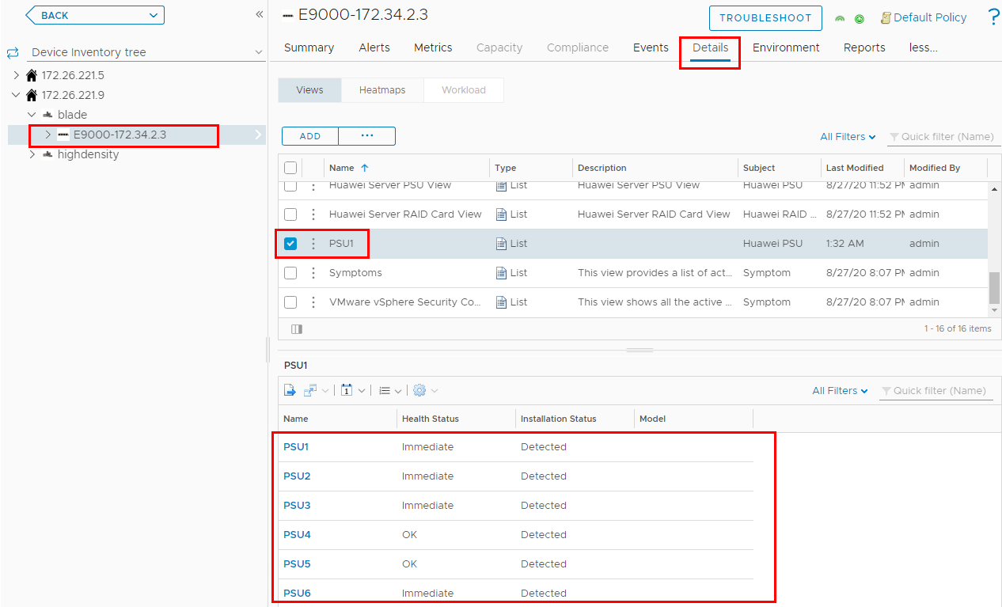

* In **Device Inventory tree**, select a server type. In the right pane, choose **Details** and click the added component view to check all views of this component type of this server type, as shown in Figure 4-14.

Viewing the component view 2

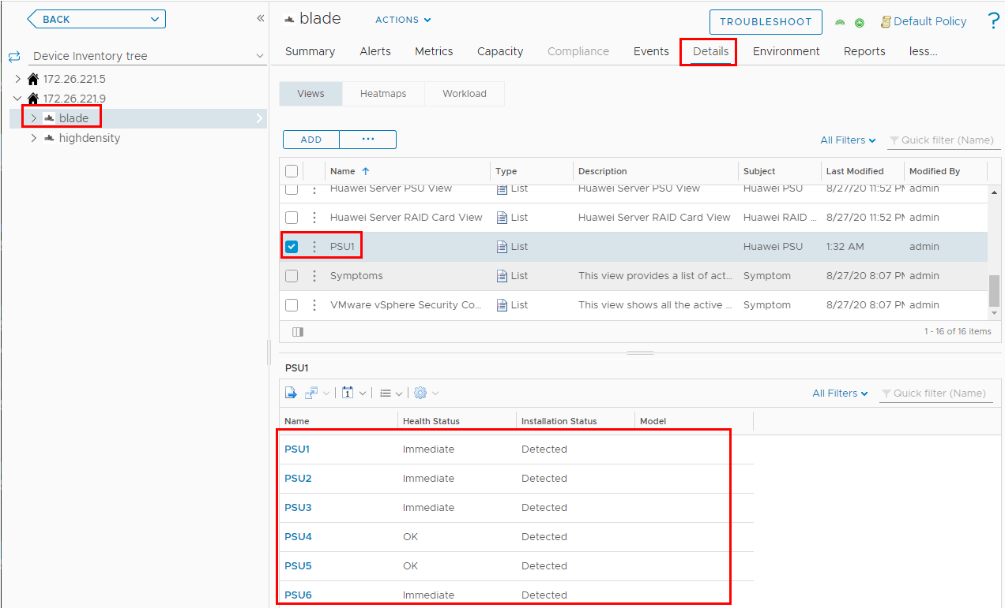

* In **Device Inventory tree**, select an eSight IP address. In the right pane, choose **Details** and click the added component view to check all views of this component type of this eSight instance, as shown in Figure 4-15.

Viewing the component view 3

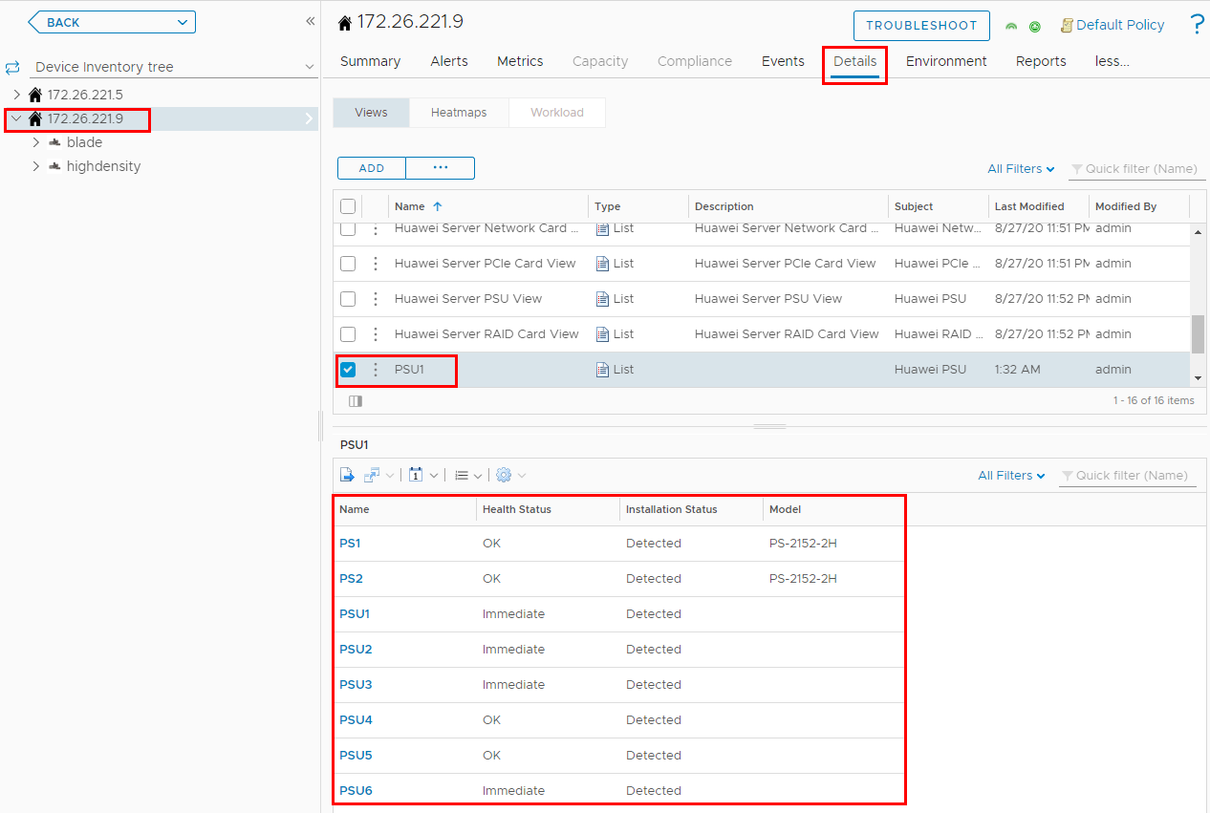

----End

## Locating Alert Information

On the vROps WebUI, choose **Alerts**.

The **Alerts** page is displayed.

In the navigation pane, choose **Triggered Alerts**.

The **Triggered Alerts** page is displayed.

Select **Object Type** from the **Group By** drop-down list box.

In the alarm column of the component for which the alarm is generated, click to expand the list and click **Triggered On**, as shown in Figure 4-16.



You can only select a component, not a component group. Otherwise, the alerted server cannot be located.

All alerts

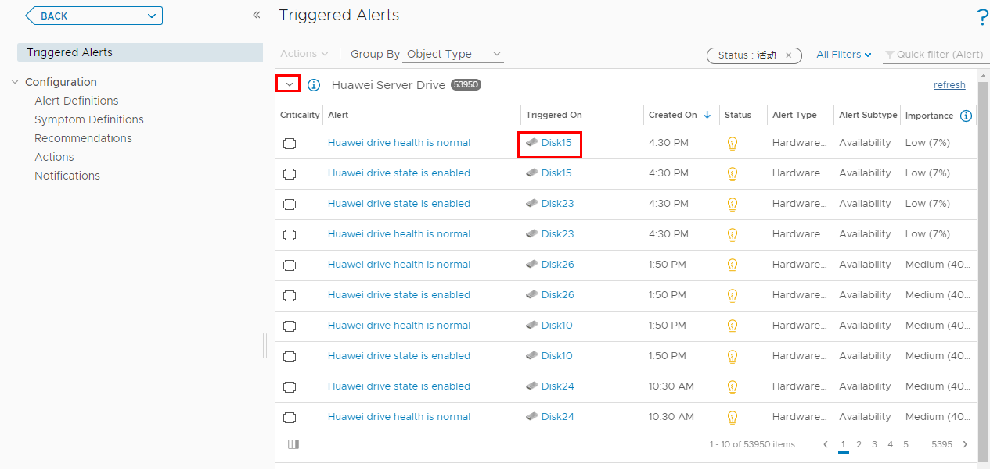

The page about the triggered object is displayed, as shown in Figure 4-17.

Triggered object

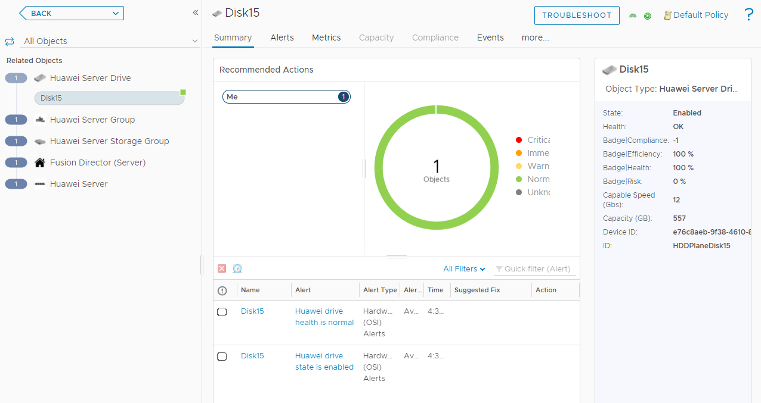

In the navigation tree on the left, click an object (such as Huawei Server Group or Huawei Server) to view the server to which the trigger object belongs.

----End

# Querying the Huawei vROps Plug-in Version

On the vROps WebUI, choose **Administration**.

The **Administration** page is displayed.

In the navigation pane on the left, choose **Repository**.

The **Repository** page is displayed.

Check the current version of the Huawei vROps plug-in, as shown in Figure 5-1.

Viewing the plug-in version

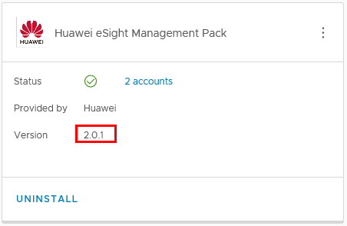

----End

# FAQs

6.1 Connection Test Failed When Adding an eSight

## Connection Test Failed When Adding an eSight

Symptom

After an eSight server is added, a failure message is displayed during the connection test.

Cause

* The user name or password is incorrect.
* The eSight northbound interface user is locked.
* A whitelist has not been set.

Solution

* The user name or password is incorrect.

Enter the user name and password of the eSight northbound interface user. To view the user name and password, perform the following steps:

* 1. Log in to the eSight WebUI.
  2. Choose **System** > **User Management** > **User**. The **User** page is displayed.

The role of the eSight northbound interface user is **Open API user group**, and the user name is displayed under **User Name**.

Viewing information about the eSight northbound interface user



* 1. Click to display the dialog box for resetting the user password.



Reset Password

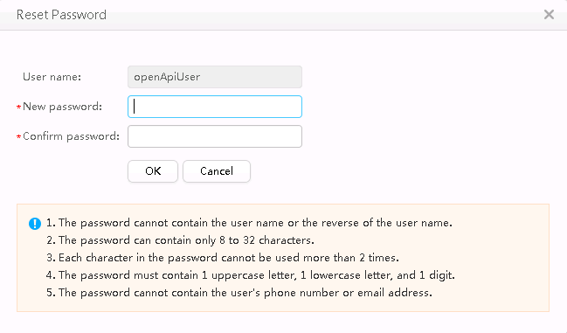

* 1. Enter a password in **New password** and **Confirm password**.
  2. Click **OK**. The password is reset.
* The eSight northbound interface user is locked.

To unlock a user, perform the following steps:

* 1. Log in to the eSight WebUI.
  2. Choose **System** > **User Management** > **User**.

The **User** page is displayed.

* 1. Click to set **Status** of the eSight northbound interface user to **Enabled**.



Unlocking a user



* A whitelist has not been set.

By default, a whitelist of eSight northbound ports is configured. To add an eSight system properly, you must add the IP address of the server where vROps is located to the whitelist of eSight northbound ports.

* 1. Log in to the eSight WebUI.
  2. Choose **System** > **Northbound Integration** > **Third-party System** > **Create**.

The **Third-party System** page is displayed, as shown in Figure 6-4.

Third-party System



* 1. Set the following parameters:
  2. **IP address**: Set this parameter to the IP address of the vROps server.
  3. **Protocol type**: Select **HTTPS** and deselect other protocols.
  4. **System ID**: Retain the default value or enter a new value. The value can be an IP address or a string of 1 to 64 characters, including digits (0-9), lowercase letters (a-z), uppercase letters (A-Z), and special characters @_- (), .^$~`!.
  5. Click **OK**.

The IP address of the vROps server is set as a whitelist, as shown in Figure 6-5.

Set successfully



1. Getting Help

If you encounter any problems during routine maintenance or troubleshooting, contact Huawei technical support engineers.

* 1. Collecting Fault Information

Before troubleshooting, obtain the following information:

* Customer company and address
* Contact person and telephone number
* Time when the fault occurred
* Detailed fault symptom
* Device type and software version
* Any measures taken and effects
* Fault severity and expected rectification deadline
  1. Preparing for Debugging

When you seek Huawei technical support, Huawei technical support engineers may assist you in performing some operations to further collect fault information or rectify the fault.

Before contacting technical support engineers, prepare the spare parts for boards and port modules, screwdrivers, screws, serial cables, and network cables.

* 1. Using Product Documentation

Huawei provides the documents delivered with the equipment. This document provides guidance for you to solve common problems that occur during routine maintenance or troubleshooting.

To better rectify the fault, you are advised to use the guide before contacting Huawei technical support engineers.

* 1. Obtaining Technical Support

Huawei's timely and efficient response is available from:

* Local branch offices
* Secondary technical support system
* Telephone support
* Remote support
* Onsite support

Technical Support Website

Obtain technical documents at [Huawei Technical Support](https://support.huawei.com/enterprise/en/index.html) website.

Self-Service Platform and Community

Learn more about servers and communicate with experts at:

* [Computing Product Information Service Platform](https://support-it.huawei.com/server/#/home) for specific server product documentation.
* [Huawei Enterprise iKnow](https://support.huawei.com/iknow/?source=SupportE) for quick learning about products.
* [Huawei Enterprise Support Community (Servers)](https://forum.huawei.com/enterprise/en/Server/forum/895) for learning and discussion.

News

For notices about product life cycles, warnings, and updates, visit [Support > Bulletins > Product Bulletins](https://support.huawei.com/enterprise/en/bulletins-product).

Cases

Learn about server applications at [Computing Case Library](https://support-it.huawei.com/server-knowledgebase/#/home).



The Computing Case Library is available only to Huawei partners and Huawei engineers.

Huawei Technical Support

If a fault persists after taking the above measures, obtain technical support in the following ways:

* Contact Huawei customer service center.
* Enterprise customers

Send emails to [support_e@huawei.com](mailto:support_e@huawei.com) or visit [Global Service Hotline](https://e.huawei.com/en/service-hotline-query).

* Carriers

Send emails to [support@huawei.com](mailto:support@huawei.com) or visit [Global TAC Information](https://support.huawei.com/carrier/docview!docview?nid=IN0000034614).

* Contact technical support at your local Huawei office.